**TEST REPORT – 08.12.2023** [**https://www.pothys.com/**](https://www.pothys.com/)

**Retested & Closed Issues:**

1, Heart not changing the color in Wishlist button if the user accidently clicks the outer circle of the button only. Please make the full button is responsible to change the heart’s color.

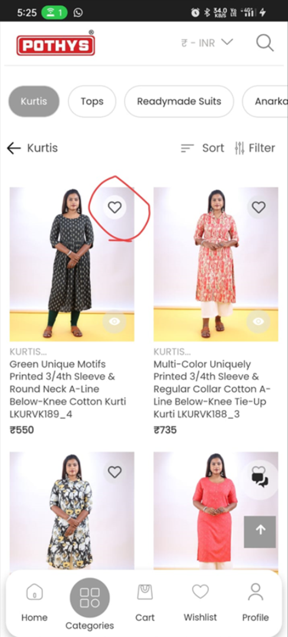

**Fixed:**

